Week 6 Activities

Design Approach: Use of paper [1] was followed to simulate a patch (rectangular microstrip) antenna design using ADS Momentum. The design is shown in Figure 1. The main tradeoff determined is the bandwidth and the S11 reflection parameter. The better one becomes, the worse the other becomes.

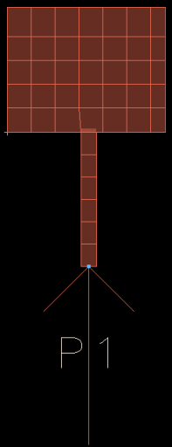

Figure 1. Antenna design in ADS Momentum.

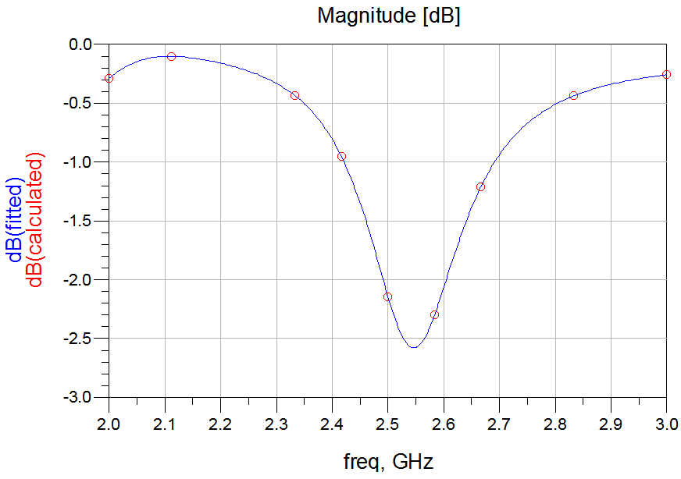

Figure 2. Simulation result of the patch antenna at 2.5 GHz.

Since the results were not very good, the antenna was not built in the EPL. An alternative was found and research into a quarter-wavelength ground plane antenna showed some potential. An example of the antenna design is shown in Figure 3. The calculations for the lengths needed for the antenna are shown in Table 1. However, due to time limitations, the antenna was not constructed or tested.

Table 1. Lengths for the quarter-wavelength antenna.

|  |  |  |
| --- | --- | --- |
| Parameter | 2.4 GHz | 2.6 GHz |
| Length (cm) | 1.481392 | 1.367439 |

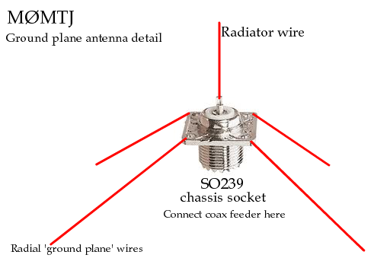

Figure 3. Example of quarter-wavelength ground antenna. See [2] for more information.

References:

[1] Behdad, Nader. Simulation of a 2.4 GHz Patch Antenna using ADS Momentum, Spring 2007.

[2] http://www.mds975.co.uk/Content/amateur_radio_antennas_06.html